V International Congress of the John Gower Society 2023
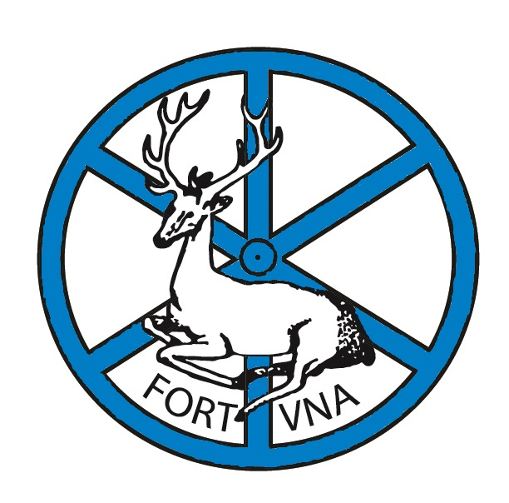
Gower in Contexts: His Words, His Books, His Heritage
University of St Andrews, Scotland, 7-10 July, 2023

Contents

Conference Programme | 3
List of Delegates | 15
Saturday activities | 19
Recommended restaurants | 20
Map of St Andrews | 21
Emergency numbers | 22
All plenary and parallel sessions take place in Schools 1, 2, and 3, in St Salvator's College quadrangle: these lecture rooms are located along the east side of the quad.
Lower College Hall, on the north side, is where to go for tea and coffee breaks, lunches, and the Sunday gala dinner.
The Friday wine reception is in Lower College Hall; the wine reception before the gala dinner is in Upper College Hall (directly above). Dinner on Friday and Monday is at Agnes Blackadder Hall on the North Haugh.
FRIDAY 7 JULY

2pm-3.15pm Registration (Lower College Hall)

3.15pm Welcome and Introduction from Professor Margaret Connolly
(Lower College Hall)

3.30-5pm Parallel Sessions
I. Manuscript and Text
School 1
Chair: Margaret Connolly, University of St Andrews
1. Phoebe Macindoe, University of St Andrews
“The Pursuit of Perfection: Blank Spaces in the Confessio Amantis MS Hunter 7”
2. Demi Wormgoor, Independent Scholar
“When is a ‘Confessio Amantis Manuscript’ Not Just a Confessio Amantis Manuscript?”
3. Tamara O’Callaghan, Northern Kentucky University and Andrea R. Harbin, State University of New York, Cortland
“’To wite how that thin eye hath stonde’: Gazemapping and the Reading Experience of Gower’s Manuscripts”

II. Gower Meets the Machine
School 2
Chair: Brian Gastle, Western Carolina University
1. Zachary C. Engledow, Indiana University
“’I’ll offer tears instead of ink’: Sex, Gender and the Posthuman in John Gower’s Cronica Tripertita”
2. Curtis Runstedler, University of Stuttgart“
Promethean Ambitions and Grosseteste’s Medieval Robot in the Confessio Amantis”

III. Gower and Performance
School 3
Chair: Ana Sáez Hidalgo, University of Valladolid
1. Jeffery G. Stoyanoff, Pennsylvania State University, Altoona
“Gower’s Wisdom: Book VII of the Confessio Amantis and the Morality Play”
2. Elisabeth Dutton, University of Fribourg
“Gower Goes to Switzerland: The Swiss Stage Bards’ Multilingual Production of Pericles, Prince of Tyre”
3. Gillian Redfern, University of Manchester
“Creaturely Comfort: Medieval Drama’s Comfortable Responses to John Gower’s Animal/Human Pairings in the Vox Clamantis”
5pm-6pm Plenary 1
School 3
Ann Astell, University of Notre Dame
Gower’s Constantine: Between Hagiography and Morality

6pm-7pm Wine Reception, Lower College Hall

Opening and Welcome
University of St Andrews Deputy Principal Professor Brad MacKay

7.30-8:30pm Dinner at Agnes Blackadder Hall

8.30-10pm Forbes Bar, Agnes Blackadder Hall

Translating Gower
Catherine Carter, Western Carolina University
and
Brian Gastle, Western Carolina University

A poetry reading including selections from their modern English translation of the Confessio Amantis (forthcoming Medieval Institute Press)

SATURDAY 8 JULY

9am-10.30am Parallel Sessions
IV. Gower and the East
School 1
Chair: Matthew Adkins, Columbus State Community College
1. Amanda J. Gerber, James Madison University
“Turning Gower’s Ancient East into the Medieval West”
2. Leila K. Norako, University of Washington
“Gower’s Medea, Richard Coer de Lyon’s Cassiodorien, and the Limits of Recovery Romance”

V. Gower the Physician
School 2
Chair: Thomas Hahn, University of Rochester
1. Pamela Yee, University of Rochester
“Trauma, Recovery, and Community: Making Sense of the Confessio’s Ending”
2. Mark Ronan, University College, Dublin
“’As guile under the hat/ With sleyhtes of a tregetour/ Is hidd’: Amans’ Addiction and Recovery, and the Efficacy of Genius’ Intervention in Confessio Amantis”

VI. Making Manuscripts Readable
School 3
Chair: Michael P. Kuczynski, Tulane University
1. Linne Mooney, University of York
“The Bodmer Confessio Amantis Manuscript: Another Multi-Scribe Production”
2. Siân Echard, University of British Columbia
“Adding and Subtracting: Dealing with Damage in Gower’s Manuscripts”
3. Margaret Connolly, University of St Andrews
“Reading Gower in the Seventeenth Century in Print and Manuscripts”

10.30-11am Coffee (Lower College Hall)

10.45am-1.00pm
Library Tours in small groups (3 x 45-minute visits)
Wardlaw Museum Tours in small groups (2 x 30-minute tours)
For more information on both tours see p. 19

1.00pm-2pm Lunch (Lower College Hall)

2pm-3.30pm Parallel Sessions

VII. The Gowerian Body
School 2
Chair: Craig Bertolet, Auburn University
1.. Natalie Grinnell, Wofford College
“Youth, Age, and Disability Theory in Gower”
2. Caitlin Moon, Trinity College, Dublin
“Gower’s Aged Aesthetics: The Loathly Lady, Gower, and the Inappropriate Lover”

VIII. Gower and Social Forms
School 3
Chair: R.F. Yeager, University of West Florida
1. Jeremy J. Smith, University of Glasgow
“The Language of the Confessio Amantis: The Gower Scripta and the Myth of Standard English”
2. Tim William Machan, University of Notre Dame
“Gower and the History of English”
3. Alastair J. Minnis, Yale University
“Gower’s ‘Honest Love’ Revisited”

3.30-4.00pm Tea (Lower College Hall)

4.00-5:30 Parallel Sessions

IX. How Tales Are Told
School 1
Chair: Kara McShane, Ursinus College
1. Brian W. Gastle, Western Carolina University
“Object Lessons: Gower’s ‘Tale of Acteon’ as the Confessio’s Primum Mobile”
2. Matthew W. Irvin, University of the South
“A Polemic on Pity: John Gower’s Piteous Policy”
3. Andrea Schutz, St. Thomas University
“Tau(gh)t Tautologies: Gower Takes us to School”

X. French (and Other) Connections
School 2
Chair: Natalie Grinnell, Wofford College
1. Ruen-chuan Ma, Utah Valley University
“Mixed Visual Modes and Mixed Tongues: Re-evaluating Gower’s Bilingualism”
2. Geoff Rector, University of Ottawa
“Entering the Community of Lovers: Impersonation, Inclusion, and Reading Communities of Gower’s Cinkante Balades”
3. Linda Barney Burke, Elmhurst College
“Scattered Rhymes: Gower's Cinkante balades at the Turn of the Early Modern, Part 2: The Sonnet Sequences of Spenser and Shakespeare”

Evening: delegates are free to explore the wide range of bars, pubs, and restaurants St Andrews offers (see p. 20 for some suggestions or ask a local!)

SUNDAY 9 JULY

9.30-11am Parallel Sessions

XI. Gower and Lydgate (and Hoccleve)
School 1
Chair: Siân Echard, University of British Columbia
1. R.D. Perry, University of Denver
“Constantine in Gower and Lydgate”
2. Eve Salisbury, Western Michigan University
“Peace Signs: Health and the Body Politic in Gower and Lydgate”

XII. Sources and Analogues
School 2
Chair: Margaret Connolly, University of St Andrews
1. Kelsey Shearman, University of Birmingham
“Politics, Prophecy, and Exemplars: John Gower’s Use of Sources in the Confessio Amantis”
2. Gabriel Ford, Drake University
“Seven Sages of Rome and Disciplina Clericalis as Analogues: Two Frametales Circulating in Gower’s England”
3. Lucy Turton, University of St Andrews
“Confessio Peccatoris: Gower and the Influence of Handlyng Synne”

XIII. Telling Tales
School 3
Chair: Ana Sáez Hidalgo, University of Valladolid
1. Thomas Hahn, University of Rochester
“Gower’s Tales of Moises and Tarbis (Confessio Amantis IV.645 ff.)”
2. Emily McLemore, University of Notre Dame
“’You Should See My Crown’: Cruelty and Conquering in Gower’s ‘Tale of Albinus and Rosemund’”
3. Miriamne Krummel, University of Dayton
“John Gower’s Disputation: The ‘Tale of the Jew and the Pagan’”

11-11.30am Coffee (Lower College Hall)

11.30am-1pm Parallel Sessions

XIV. Structures
School 1
Chair: Tim William Machan, University of Notre Dame
1. Bard Swallow, University of Toronto
“Structural Use of Rhyme in the Viciorum Pestilencia”
2. Kerstin Majewski, Ludwig-Maximilians University
“Word-Formation in the Confessio Amantis”
3. Eric Weiskott, Boston College
“After Gower’s Caesura: Lateness, Latin, and Manuscripts as Monument”

XV. Ovidian Voices
School 2
Chair: Alastair J. Minnis, Yale University
1. Taylor Cowdery, University of North Carolina, Chapel Hill
“Which Ovid Did Gower Use?”
2. Frank Coulson, The Ohio State University
“Editing and Translating Pierre Bersuire’s Ovidius moralizatus: Problems and Perspectives”

XVI. Gower and…
School 3
Chair: R. F. Yeager, University of West Florida
1. Simon Meecham Jones, Independent Scholar
“Gower and Error”
2. Michael P. Kuczynski, Tulane University
“Gower and the Wycliffite Bible”
3. Robert R. Edwards, Pennsylvania State University
“Gower and the Sublime”

1pm-2pm Lunch (Lower College Hall)

2pm-3.30pm Roundtable

XVII. Gower Across the Disciplines: French and English: A Roundtable
School 3
Moderator: R. D. Perry, University of Denver
1. Thari Zweers, Cornell University
“Holistic Gower: The Pervasiveness of Gower’s Trilingualism”
2. Sarah O’Brien, University of Maryland, Baltimore
“The Frenches of Westminster in John Gower’s Mirour”

3.30pm- 5:15pm Free time to explore St Andrews

3.30pm-4.30pm Extraordinary Lecture (20 people, sign up at registration; meet outside School 3)
Julian M. Luxford, Professor of Art History, University of St Andrews
“St. Salvator’s College and the Medieval Maces”
University Museum and University Chapel

5.15pm-6.15pm Plenary 2
School 3
Andrew Galloway, Cornell University
Vernacularity after Gower

6.15pm-7.15pm Wine Reception (Upper College Hall)
Hosted by the School of English, University of St Andrews

7.30-10pm Gala Dinner (Lower College Hall)

MONDAY 10 JULY

9.30-11am Parallel Sessions

XVIII. Fiction-Making
School 1
Chair: Kara McShane, Ursinus College
1. Jonathan Stavsky, Tel Aviv University
“’Nec sit michi fabula blesa’: Fable, Feigning, and Fiction in Gower”
2. Stephanie Batkie, University of the South
“Repetition and Difference: Ordinatio and Forms of Critique in Gower’s Langlandian Vox”
3. Georgiana Donavin, Westminster College
“The Meaning of Gower’s Marian Endings”

XIX. Gower and Maps
School 2
Chair: Craig Bertolet, Auburn University
1. Malte Urban, Aberystwyth University
“Mapping and Tracking the Floating Wor(l)ds in Gower’s ‘Tale of Constance’”
2. Colin J. Keohane, University of Victoria
“Travel, Transformation, and Translation in the Maritime Networks of Confessio Amantis after the ‘forme of Mappemounde’”
3. Elizabeth Brissey, Auburn University
“Making Space in the Confessio Amantis: Authorship and Geography in ‘Apollonius of Tyre’”
4. Valerie B. Johnson, University of Montevallo
“Maps that Bend and Fold: Softening Borders between Dream and Geography in the Confessio Amantis”

11-11.30am Coffee (Lower College Hall)

11.30am-1pm Parallel Sessions

XX. Gower and Social Theory: A Roundtable
School 1
Moderator: R.F. Yeager, University of West Florida
1. Robert Epstein, Fairfield University
“On Polyani”
2. Craig Bertolet, Auburn University
“On Agamben”

3. Matthew W. Irvin, University of the South
“On Ranciere”
4. Jeffrey G. Stoyanoff, Pennsylvania State University, Altoona
“On Latour”

XXI. By the Book
School 2
Chair: Tim William Machan, University of Notre Dame
1. Ana Saéz-Hidalgo, University of Valladolid
“Tyrwhitt’s Gower: Editorial Practices in the Confessio Amantis”
2. Kathleen Burt, Middle Georgia State University
“Bookish Meaning: Physical and Symbolic Books in John Gower’s Confessio Amantis”

XXII. Gower and Chaucer
School 3
Chair: Natalie Grinnell, Wofford College
1. Xiaoling Wu, Zhejiang University of Finance and Economics
“The Covert Narrative of the Controversies Over Constance”
2. Jennifer Alberghini, Baruch College
“Gower’s Balades and Chaucer’s Poetry: The Necessity of Interdisciplinarity”
3. Yun Ni, Peking University
“Allegorizing Innocence: Constance on Trial in Chaucer and Gower”

1-2 Lunch (Lower College Hall)

2pm-3.30pm Parallel Sessions

XXIII. Networks as Contexts in the Confessio Amantis: A Roundtable
School 1
Moderator: Jeffery G. Stoyanoff, Pennsylvania State University, Altoona;
1. Valerie B. Johnson, University of Montevallo
“Educational Ecologies: Engagement with Gower’s ‘Tale of Philomena’”
2. Samantha Katz Seal, University of New Hampshire
“Monogenesis and the ‘Moral’ Gower: Making Racial Networks in the Confessio Amantis”
3. Kara McShane, Ursinus College
“Networks of Commemoration in Gower’s Confessio Amantis”

XXIV. Re-Readings: Words and Texts
School 2
Chair: Roger A. Ladd, University of North Carolina, Pembroke
1. Clare Fletcher, Trinity College, Dublin
“’Ha wicke tunge’: Linguistic Treachery and Semiotic Trickery in the Confessio Amantis”
2. Malek J. Zuraikat, Yarmouk University
“’A bok for engelondes sake’: Gower’s Confessio Amantis Reconsidered”
3. David Watt, University of Manitoba
“’Miscreantz’ in Gower’s ‘In Praise of Peace’ and Hoccleve’s Regiment of Princes”

XXV. Francophonics
School 3
Chair: R. F. Yeager, University of West Florida
1. Clotilde Dauphant, University of the Sorbonne
“The Influence of Eustache Deschamps’s ‘Moral Ballad’ in the Traitié pour essampler les amantz marietz”
2. Elizaveta Strakhov, Marquette University
“Eneidos bucolis and Translatio studii on the Francophone Continent”
3. Yoshiko Kobayashi, University of Tokyo
“Sacramental Views of Peace and Marriage in the Poems of the Trentham Manuscript”

3.30-4pm Tea (Lower College Hall)

4pm-5.30pm Parallel Sessions

XXVI. Money Makes the World Go Round
School 1
Chair: Brian W. Gastle, Western Carolina University
1. Thari Zweers, Cornell University
“Lady Wool and Lady Meed; Gower’s and Langland’s Courtly Ladies of Disrepute and Mediterranean Mercantilism”
2. Craig Bertolet, Auburn University
“Making Change: Money and Commerce in Gower’s Mirour de l’Omme”
3. Roger A. Ladd, University of North Carolina, Pembroke
“Ladies on the Move: Women’s Trade Routes in the Confessio Amantis”

XXVII. Trauma, Health, and John Gower’s Texts: A Roundtable
School 2
Moderator: Pamela Yee, University of Rochester
1. Natalie Grinnell, Wofford College
“Health and Trauma in the Cinkante Balades”
2. Eve Salisbury, Western Michigan University
“Medea: Trauma and Transfusion”

XXVIII. Householders
School 3
Chair: Alastair J. Minnis, Yale University
1. Martha Carlin, University of Wisconsin-Milwaukee
“Secular Residents (including John Gower) in Religious Precincts, Part I: Abbey of St Clare (Minories), St Mary Overy (Southwark), and Bermondsey Abbey”
2. Caroline Barron, Royal Holloway, University of London
"Secular Residents (including Geoffrey Chaucer and John Shirley) in Religious Precincts, Part II: Westminster Abbey, St Bartholomew's Hospital, and St Helen's, Bishopsgate"

5.30pm-6pm Closing Remarks School 3 R.F Yeager

6:30pm-8:30 pm Dinner (Agnes Blackadder Hall)

8pm Postgraduates and early career academics event
Join us at Aikman’s cellar bar on Bell Street for a relaxed evening to chat to fellow early career academics. All delegates welcome, we will not check IDs at the door!

List of Delegates
Dr Gregory Matthew Adkins | Columbus State Community College
Dr Jennifer Alberghini | Baruch College
Professor Ann Astell | University of Notre Dame
Professor Caroline Barron | Royal Holloway, University of London
Dr Stephanie Batkie | The University of the South
Dr Craig Bertolet | Auburn University
Elizabeth Brissey | Auburn University
Linda Burke | Elmhurst University
Dr Kathleen Burt | Middle Georgia State University
Professor Martha Carlin | U. of Wisconsin-Milwaukee
Dr Catherine Carter | Western Carolina University
Professor Margaret Connolly | University of St Andrews
Professor Frank Coulson | The Ohio State University
Dr Taylor Cowdery | UNC-Chapel Hill
Clotilde Dauphant | University of the Sorbonne
Dr Georgiana Donavin | Westminster College
Professor Elisabeth Dutton | University of Fribourg, Switzerland
Professor Siân Echard | University of British Columbia
Professor Robert Edwards | Pennsylvania State University
Zac Engledow | Indiana University, Bloomington
Robert Epstein | Fairfield University
Dr Clare Fletcher | Trinity College Dublin
Dr Gabriel Ford | Drake University
Professor Andrew Galloway | Cornell
Dr Brian Gastle | Western Carolina University
Dr Amanda Gerber | James Madison University
Dr Natalie S. Grinnell | Wofford Colleg
Professor Thomas Hahn | University of Rochester
Dr Matthew Irvin | University of the South
Dr Valerie Johnson | University of Montevallo
Colin Keohane | University of Victoria
Dr Yoshiko Kobayashi | University of Tokyo
Dr Miriamne Krummel | University of Dayton
Professor Michael P Kuczynski | Tulane University
Frank Ladd | University of North Carolina at Chapel Hill
Professor Roger Ladd | University of North Carolina at Pembroke
Professor Julian Luxford | University of St Andrews
Dr Ruen-chuan Ma | Utah Valley University
Professor Tim Machan | University of Notre Dame
Phoebe Macindoe | University of St Andrews
Dr Kerstin Majewski | LMU Munich
Dr Emily McLemore | University of Notre Dame
Dr Kara McShane | Ursinus College
Dr Simon Timothy Meecham Jones | Independent Scholar
Professor Alastair Minnis | Yale University, University of St Andrews
Caitlin Moon | Trinity College
Professor Linne Mooney | University of York (UK)
Dr Yun Ni | Peking University
Dr Leila Norako | University of Washington
Dr Sarah O'Brien | University of Maryland, Baltimore County
Dr Tamara O'Callaghan | Northern Kentucky University
Dr R. D. Perry | University of Denver
Dr Geoff Rector | University of Ottawa
Dr Gillian Redfern | University of Manchester
Dr Mark Ronan | University College Dublin
Dr Curtis Runstedler | University of Stuttgart
Dr Ana Sáez-Hidalgo | Universidad de Valladolid
Professor Eve Salisbury | Western Michigan University (emerita)
Dr Andrea Schutz | St. Thomas University
Dr Samantha Seal | University of New Hampshire
Kelsey Shearman | University of Birmingham
Professor Jeremy Smith | University of Glasgow/University of St Andrews
Dr Jonathan Stavsky | Tel Aviv University
Dr Jeffery Stoyanoff | Penn State Altoona
Dr Elizaveta Strakhov | Marquette University
Bard Swallow | University of Toronto
Lucy Turton | University of St Andrews
Dr Malte Urban | Aberystwyth University
Dr David Watt | University of Manitoba
Dr Eric Weiskott | Boston College
Demi Wormgoor | Independent scholar
Dr Xiaoling Wu | Zhejiang University of Finance and Economics
Professor Robert Yeager | University of West Florida
Dr Pamela Yee | University of Rochester
Dr Malek Zuraikat | Yarmouk University
Thari Zweers | Cornell University

Saturday Activities

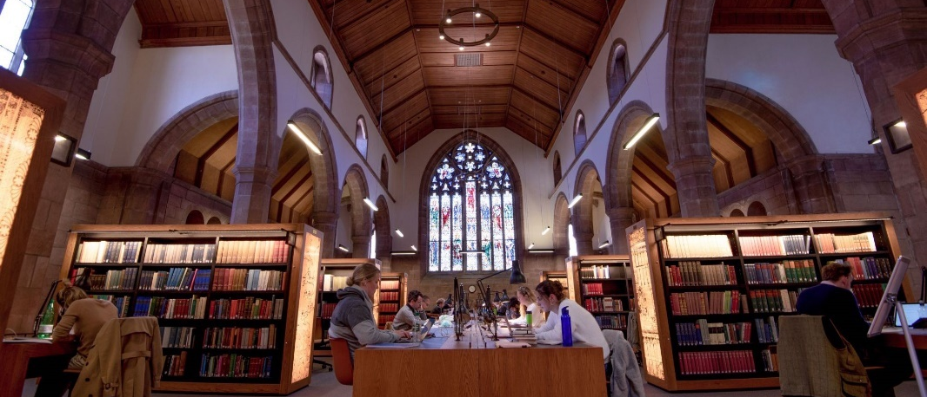

Library and special collections exhibition
Check out the special collections at St Andrews with an exhibition of manuscripts and early print editions. Featuring the edition of the Confessio Amantis favoured by Shakespeare and Milton, two Caxton imprints, fragments of the 14th-century Auchinleck manuscript, and much more. Be sure to visit to see the history of the proliferation of Gower's works from the early modern period to the Victorian medieval revival.
This exhibition has been facilitated by a grant from the Association of Manuscripts and Archives in Research Collections (AMARC).

Three tours will run on Saturday at 10:45, 11:30, and 12:15. Sign up at registration required. Meet outside Martyrs Kirk (directly across North Street from St Salvator's quadrangle).

Wardlaw museum tour
Take a guided tour of the Wardlaw museum containing artifacts from all phases of St Andrews’ history. See the (allegedly) original stool where St Andrews’ doctoral candidates took their Vivas, papal bulls, and medieval maces alongside newer chapters to our history including photography and the ever-popular Raisin Weekend.

Two tours will run on Saturday at 11am and 12pm. Sign up at St Salvator’s registration required. Meet at the Wardlaw museum on the Scores.

List of Recommended Restaurants
Coffee and drinks
Zest - social enterprise with good coffee, but service can be slow £
Starbuck’s, Pret, Gregg’s, Costa - you know the drill! All located on Market Street, can get busy around lunchtime and early afternoon £
Spoiled Life Café - really good coffee, lots of milk alternatives and vegan/GF pastries ££
Combini & Co - cute, small, good coffee and nice range of teas £
Palompo Coffee - the best proper Italian coffee in town £
Fisher and Donaldson- two locations, one a traditional bakery, the other a good quality café

Good quality median price lunch / dinners
Mitchells- British food ££
Ziggy’s - American diner, good atmosphere ££
Tanon - takeaway and dine-in, excellent Thai food ££
Tailend - fish and chips takeaway as well as sit in ££
Nandos - chain restaurant known for chicken dishes ££
Mozza - pizza chain ££
Gorgeous - tearoom with lunch foods (stairs) £
Cottage Kitchen - good selection of lunches, excellent vegan and GF cakes and pastries ££
Maisha - Indian, has a cheap early lunch and early dinner deal ££

High quality and pricey evening meals
Forgans- dinner local scottish delicacies (haggis bon bons) and a ceilidh on Friday and Saturday nights) £££
Rusacks rooftop bar - expensive but excellent views over the golf course and west sands. Perfect for cocktails ££££
Adamson - excellent food and cocktails £££
The Saint - cocktails, lunch, and dinner £££

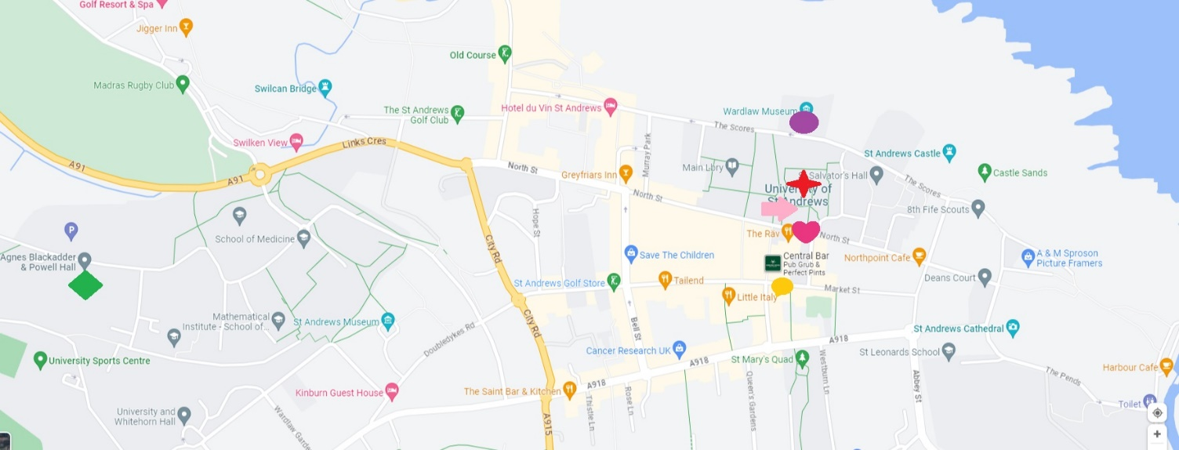

Wardlaw museum (Museum tour and location of Extraordinary Lecture)

Visit Scotland tourist centre

St Salvator’s Chapel (Location of Julian Luxford’s Lecture)
Agnes Blackadder Hall (Delegate residence)
St Salvator’s (Registration and conference location)
Martyrs Kirk Special collections (library and special collections tour)

In Case of Emergency

Emergency requiring police, fire, or ambulance 999
Security and response (for issues on campus including room lockouts): 01334 46 8999
Taxi numbers: St Andrews Taxis 01334 477271
Golf City Taxis 01334 477788

Conference organiser emails
Margaret Connolly: mc29@st-andrews.ac.uk
Robert Yeager: rfyeager@hotmail.com
Julian Luxford: jml5@st-andrews.ac.uk
Phoebe Macindoe: pm256@st-andrews.ac.uk
Lucy Turton: lt98@st-andrews.ac.uk

Emergency numbers
Margaret Connolly: 07760520973
Phoebe Macindoe (for lost delegates and problems needing a car): 07969008265
Lucy Turton (for issues at Agnes Blackadder): 07780574269

The organisers would like to thank Professor Ian Johnson (School of English) and Professor Bridget Heal (School of History) for generous financial support of this event, and Andy Eccles, Audrey Wishart, and Jane Gordon for administrative assistance. Thanks to Rachel Hart, Elizabeth Henderson, Maya Sheridan, and Alexa Zildjian for arranging the exhibition of Special Collections which was funded by a grant from AMARC. Thanks also to the Revd Dr Donald MacEwan for permitting use of the Chapel, and to the team at the Wardlaw Museum for facilitating visits. And thanks to the Conference Office, especially Vincent Van Dijk and the recently retired Audrey Bruce, for efficient planning and organisation as always.

